# Ivy Tech Community College

# School of Information Technology

# Software Development

## SDEV240 - Software Development using C#

### DESCRIPTION:

The purpose of this document is to provide further understanding of the **GROUP PROJECT**

### HOW AND WHAT TO TURN IN:

Create a Windows Form application using multiple forms. When the project is fully developed and tested create a .zip file of the project and upload it in the assignment submission link in Module 8 - M08 Group Project Part 2. All students in the group should submit a copy of the project.

### SPECIFICATIONS:

A construction company is considering building homes. The company has asked you to develop a GUI application that provides a materials list estimation. The materials list estimation will contain a table with a grand total at the bottom. The user will be allowed to enter the item description, order quantity, and unit price. The application will display a column containing the estimated cost (order quantity multiplied by unit price) and display it to the user. At the bottom of the list the application should display a total estimated cost to build the home. See the image on the next page of this document which gives a sample materials list to help you complete this project. The user can click the

* **Clear** button at any time to clear the table and begin a new materials list.
* **Save** button to save the information to a file.
* **Calculate** button to display the total estimated cost.

### BEYOND WHAT IS EXPECTED:

Add more buttons, menus, and functionality to your materials list estimation application.

Implement as much as you can of what you see of the example on the next page of this document.

* **Example idea not mentioned above-** Category subtotals
* …
* To find more examples Google Search - “Materials List Estimator” and you will see hundreds of examples where you can grab some ideas to add to your projects. ....

### SAMPLE MATERIALS LIST ESTIMATOR

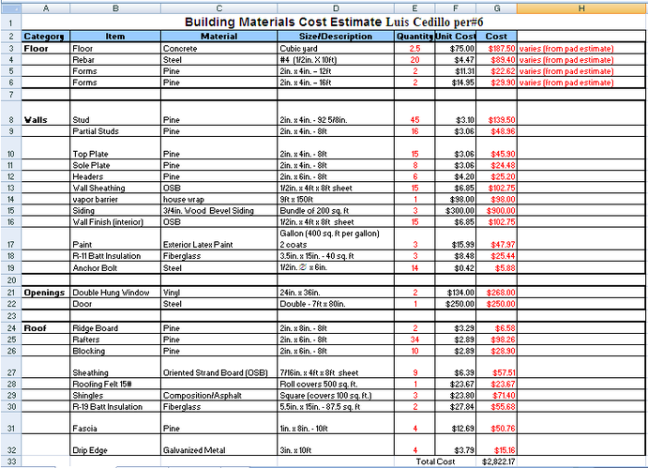

Figure 1 Sample Estimator